Guidelines for Support and Awareness of Mental Health Conditions

Living with a mental health condition can often have an impact on day to day life, making things that others might not think about a bit more difficult. These guidelines have been put together to increase your awareness of mental health conditions and help you provide general support to participants, colleagues and members of our wider community.

The Role of Innov8 Sportz

Innov8 Sportz CIC is passionate about improving the lives of people through physical activity. We value the importance of mental health awareness in our communities and understand the impact that mental health conditions have on the people whom are affected by them. By increasing the awareness of the causes and effect of mental health conditions, we aid a reduction in the social stigma’s attached to mental health. We believe its OK not to be OK!!!

Types of Conditions

There are many different mental health conditions. Some of them have similar symptoms, so you may experience the symptoms of more than one mental health condition, or be given several diagnoses at once. Or you might not have any particular diagnosis, but still be finding things very difficult. Everyone’s experience is different and can change at different times.

Depression ADHD Anxiety Personality Disorders

Panic Attacks Obsessive-Compulsive Disorder Self-Harm

Suicidal Feelings Anger Eating Disorders Schizophrenia

Paranoia Insomnia and Sleep Problems Bipolar Disorder

Phobias Dementia and Alzheimer’s Bereavement Addiction

Season Affective Disorder Post-Traumatic Stress Disorder

Postnatal Depression Body Dysmorphia and Negative Body Image
The CARE Approach was developed by UKCoaching and Mind to give physical activity providers guidelines for promoting good mental health through coaching:

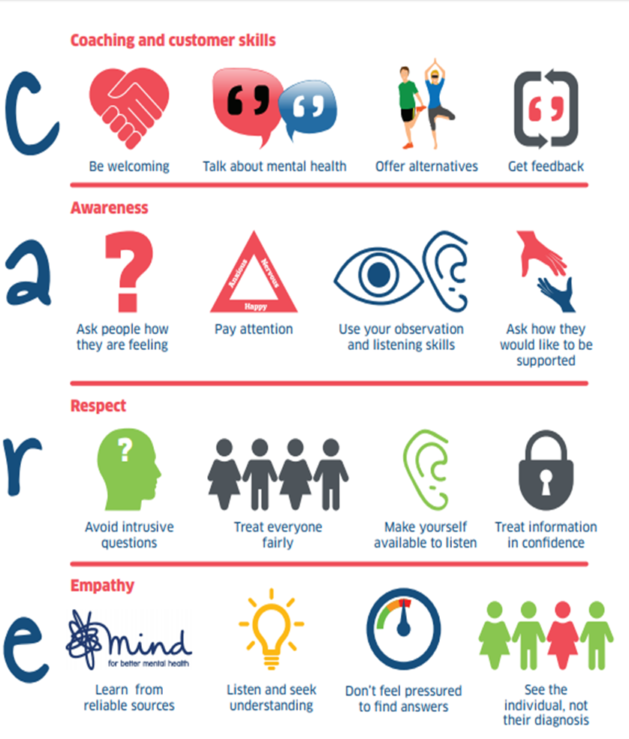

Dos and Don’ts

If a participant discloses a mental health condition, or if you suspect any individual of suffering mental discomfort, all staff should act in line with the following guidelines:

Do NOT:

- Ridicule a participant or make jokes about their condition.
- Expose participants to extreme pressure or unacceptable levels of stress
- Condone behaviour in other participants that leads to individuals with Mental Health Conditions being ridiculed or ostracised from the group.
- Cause an individual to lose self-esteem by embarrassing, humiliating or undermining the individual.
- Treat some participants more favourably than others.

DO:

- Be approachable to all participants, make yourself available for individuals to talk to you.
- If your concerned about someone, ask them privately if they are OK.
- Get to know all participants, try to understand what their motivations and goals are and what is “usual” behaviour for them.
- Integrate mental health awareness talks into session delivery, where appropriate
- Be aware of how to contact organisations for information and support. These include Mind, Rethink, NHS Trusts, CAMHS, Heads Together, Young Minds, The Mix and Samaritans
- Sign post participants to organisations where they receive further help and support
- Keep Sessions fun, as excess pressure can make anxiety levels worse.
- Challenge inappropriate behaviour. The way others behave can impact on someone with a mental health problem
- Encourage social activities. Many people feel anxious when joining a group so ensure we create supportive environments where everyone feels welcome and valued.
- Speak to your Head Coach or our CEO if you have any concerns or need support.

This policy was adopted by Innov8 Sportz CIC in October 2017 and is due to be reviewed in October 2018. Signed:

