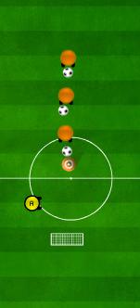


Main content
Aim of the drill
To improve the participants abilities to strike a moving ball

Set up
As shown in image

Rules participants pass to coach, coach passes back participants strikes ball at target

This drill is used to improve:
- Striking a moving ball
1-2 shooting



Progressions:
- Add a goalkepper or defender
Regressions:
- Strike a dead ball

Notes
This Drill Could be used when coaching:
- Football
- Basketball
- Uni-hoc
- Tag rugby

