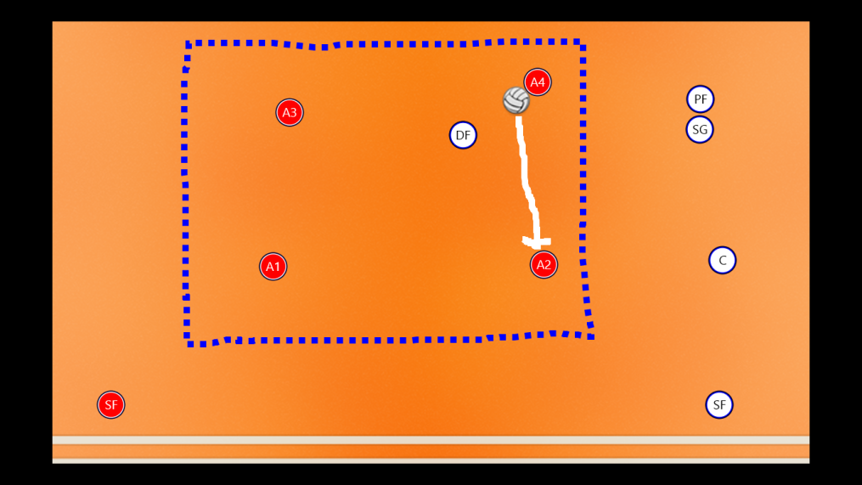

This drill is used to improve:

* Teamwork
* Confidence
* Communication
* Decision Making
* Spatial Awareness
* Pass Selection
* Passing Accuracy
* Passing Under Pressure
* Receiving a pass
* Body positioning
* Pass and move

**Passing**

Aim of the drill

The aim of this drill is for the attacking players (Reds) to make 5 consecutive passes without the Defender (White) Intercepting a pass or the ball leaving the grid. If the Attackers make 5 passes they get a point, but if the defender stops the attackers then the defender gets the point. Play best of 3 games and then rotate the defender so everyone has a chance at both roles.

Set up

* Mark out a 10x10y box for each group
* Sort into groups of 5 (Can be done 3v1 if numbers dictate).
* Select a defender in each group
* Give each group a ball
* Play!!

Rules

* No Fouling (automatic point to fouled player)
* Attackers must keep the ball inside the box at all times
* Rotate defenders fairly
* No Dribbling (Pass and then move)

**4v1 – Possession Game**



Progressions:

* Add an additional defender to make the game 3v2.
* Limit amount of touches each player is allowed in possession of the ball.
* Make the Grid smaller 5y x 5y to improve ball control and pass selection

Regressions:

* Take Defender away to take away pressure
* Make 3 consecutive passes to score a point
* Make Box bigger 15y x 15y
* Make defender Passive (NO tackling )
* Stand in corners and pass corner to corner





Notes

This Drill Could be used when coaching:

* Football
* Tag Rugby
* Basketball + Netball (only allow pivot movements in possession
* Tchoukball (add frame, 3passes then shot, defender must catch shot to win point)
* Handball



