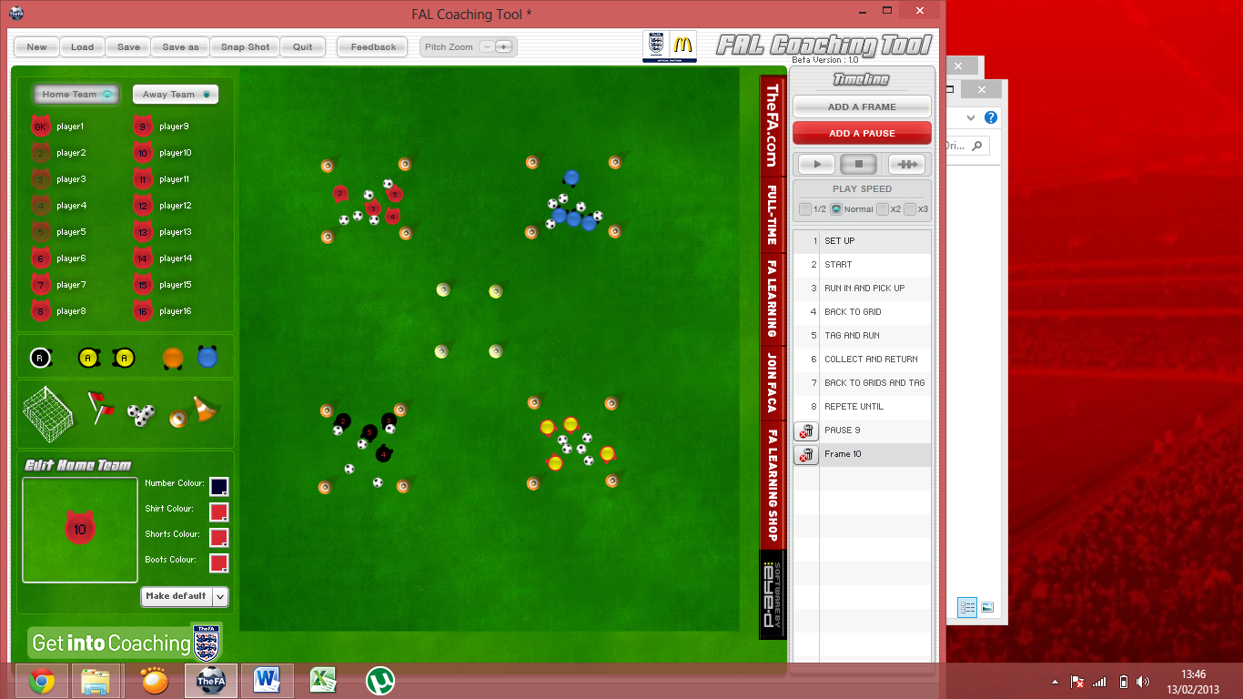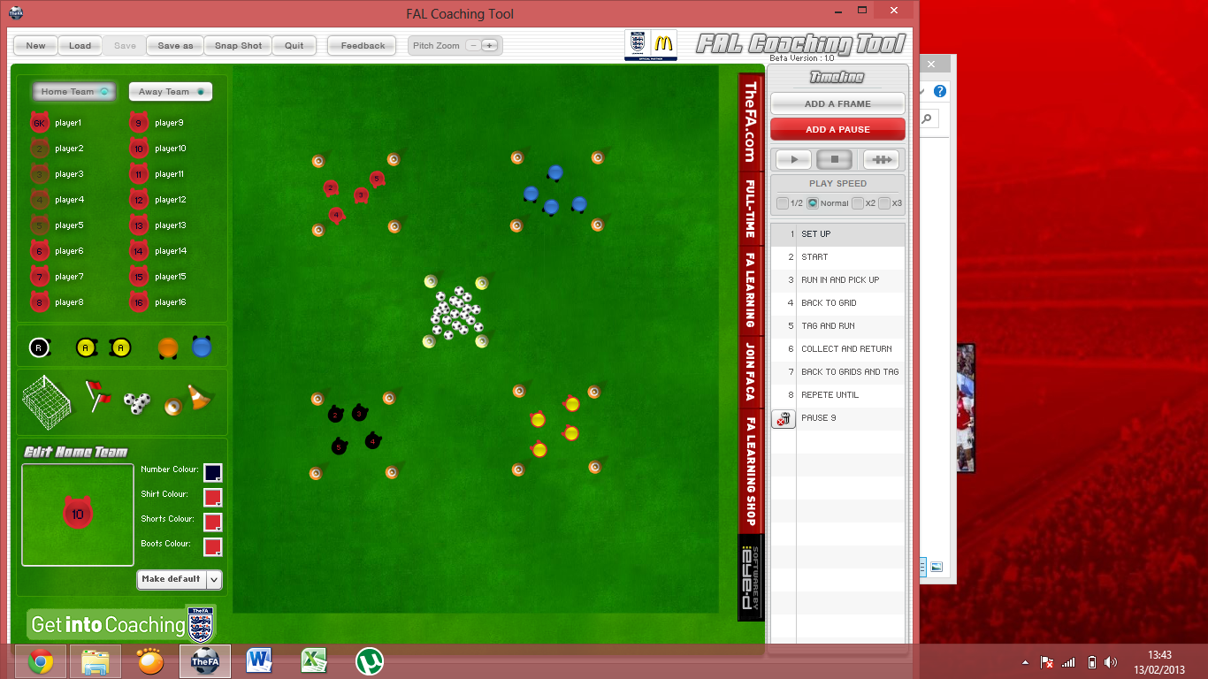

**Dribbling/ Handling**

Aim of the drill

The aim of the game is to take it in turns (one player per team per go) to run to the middle zone, collect a ball and return it to their team. The game continues until all the balls are out of the middle zone and safely inside the team’s areas. The team with the highest number of balls at the end of the game wins.

Set up

* Mark out 5 square areas of the same size (use different colours so you can have team colours)
* Arrange groups in to teams (Min of 2 teams)
* Place balls in the Middle zone

Rules

* Participants must take it in turns (Form Lines).
* Each participant can only take one item per visit.
* Next player in the line must wait for the ball to be placed inside their team’s box before leaving to collect the next one.
* Once all the balls are gone the game stops.

This drill is used to improve:

* Teamwork
* Confidence
* Co-ordination
* Spatial Awareness
* Decision Making
* Dribbling/Handling
* Keeping Head Up
* Turning
* Using Both Hands or Feet
* Ball Control

**Collect, Steal and Return**



Progressions:

* Once the all the balls are out of the middle grid shout “Steal”. Now players can steal a ball from another team (one ball per player per trip).
* Shout “Return” and players must get all the balls back into the middle zone and return to their own grid (first group with a clear area wins)
* Put a Time limit on the Game (2 Mins to get as many balls as possible).

Regressions:

* Only use Bibs as items if players are finding it hard to carry or dribble.
* Turn the drill into mini-relay races (run into the middle area, turn and run back to group.
* Allow more than one player per team collecting at once. (speeds game up)





Notes

This Drill Could be used when coaching:

* Football (Players Must dribble ball Using correct dribbling Technique)
* Tag Rugby (Could use tags as well as balls)(1 Point for Tag, 2 For a Ball)
* Uni-Hoc (Use sticks to collect balls)
* Basketball ( Players must Dribble Basketball)
* This game to be re-structured to many other sports (Be creative!!)



