

**Main content**

Aim of the drill

To improve the passing and receiving ability of the participants

Set up

Set up a small box inside a larger one half the participants inside the small box the other half around the edge of the big box with a ball

See animation for game play of the drill

Rules

Participant on the inside must go back through the inside box after every pass

This drill is used to improve:

* Passing and receiving

**Half in half out**

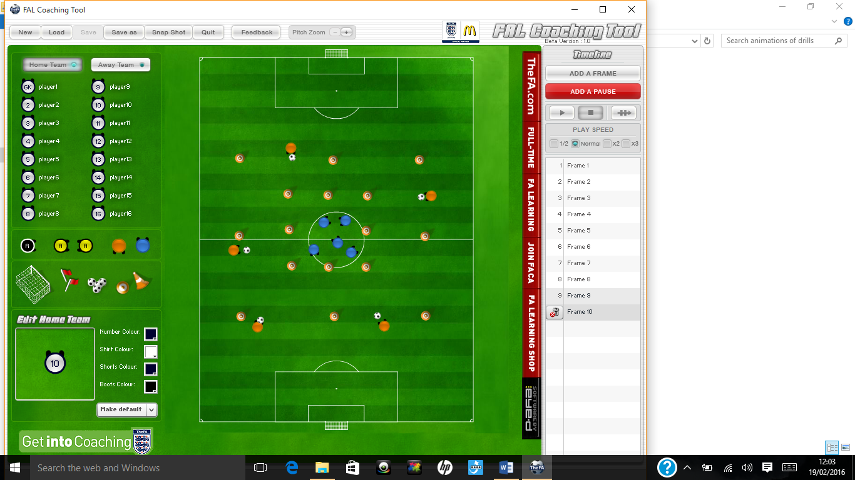



Progressions:

* Defenders
* Lofted pass
* First touch return

Regressions:

* Make it static





Notes

This Drill Could be used when coaching:

* Football
* Tag rugby
* Basketball
* Uni-hoc



