

Main content
Aim of the drill
To improve dribbling / passing and receiving drills of participants

Set up
A ball between two moving round the grid and passing the ball

Rules

This drill is used to improve:
- Dribbling
- Passing and receiving
- Turning
Move in twos
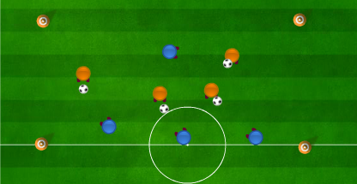



Progressions:
- defender that swaps places with whoever he/ she can take the ball off
Regressions:
- Don’t allow movement

Notes
This Drill Could be used when coaching:
- Football
- Tag rugby
- Basketball
- Uni-hoc
- Flag football

