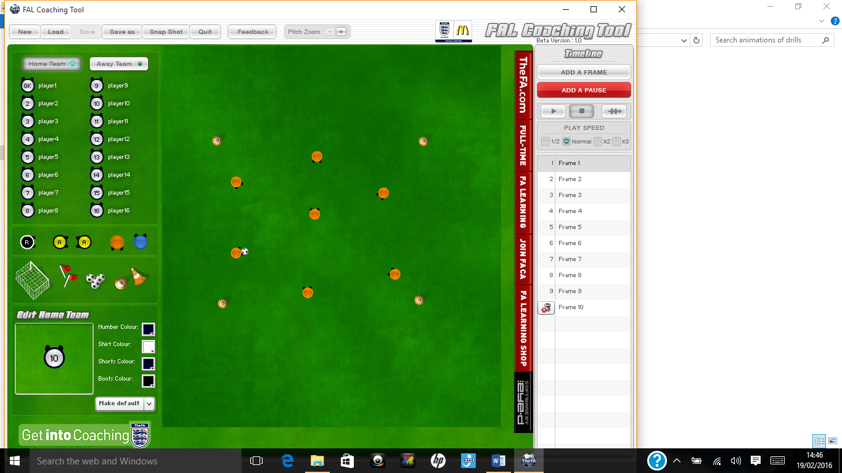

**Main content or warm up**

Aim of the drill

To improve passing and receiving of participants

Set up

players round the outside have to pass the ball so the middle player cant touch it

Rules

If a player on the outside gives the ball away they swap with the middle player

This drill is used to improve:

* Passing and receiving

**Piggy in the middle**



Progressions:

* Add a second middle man or a second ball

Regressions:

* Remove middle man





Notes

This Drill Could be used when coaching:

* Basketball
* Football
* Tag rugby
* Uni-hoc



