

**Main content**

Aim of the drill

To improve the passing and reciving ability of participants

Set up

As shown in picture to concentric circles of participants inner circle with balls

Rules

Passing back and forth to begin

This drill is used to improve:

* Passing and receiving

**Round the clock**

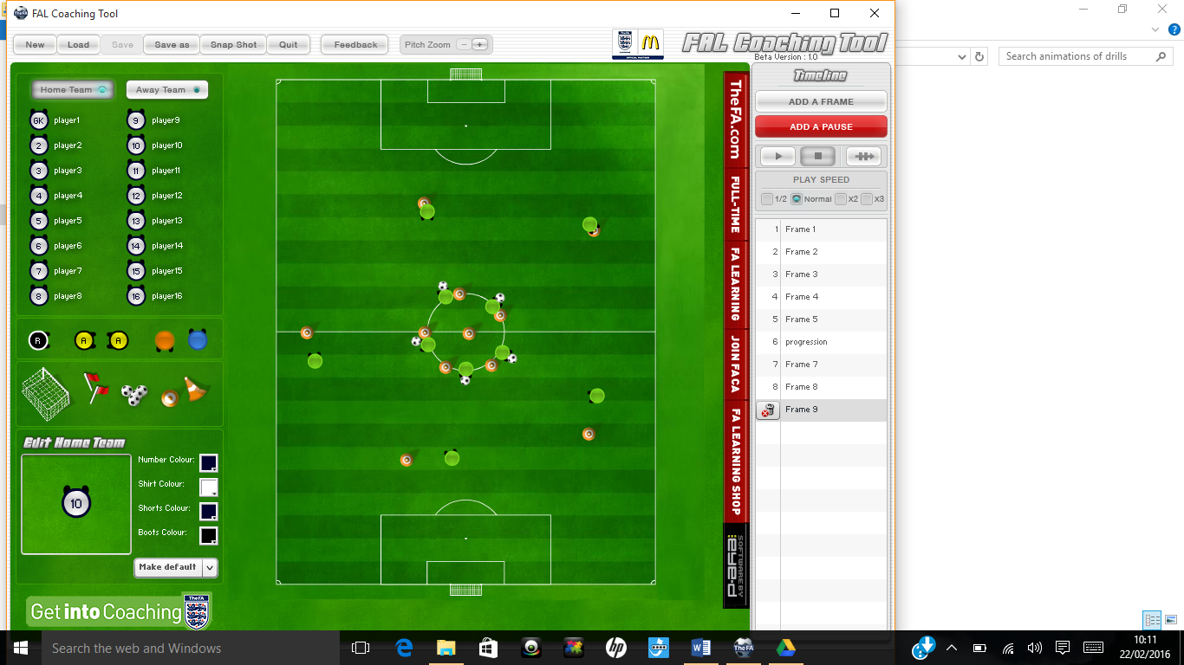



Progressions:

* Inner circle must run to centre and back and outer circle rotate see animation

Regressions:

* Closer or straight line passing





Notes

This Drill Could be used when coaching:

* Football
* Basketball
* Tag rugby
* Uni-hoc



