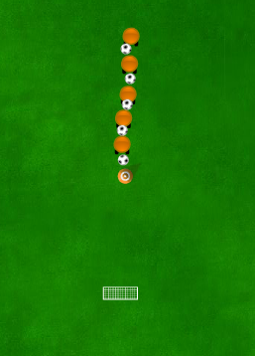


Main content
Aim of the drill

To improve participants finishing techniques

Set up

A ball per player 1 touch and strike the ball at goal

Rules

This drill is used to improve:
- Finishing
Straight line shooting



Progressions:
- Smaller goal
- Goalkeeper
Regressions:
- Closer to goal
- Larger target
- Dead ball

Notes
Different technique dependent on sports
This Drill Could be used when coaching:
- Basketball
- Football
- Uni-hoc

