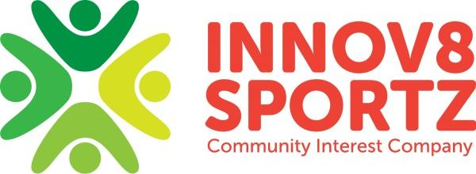
Health and Safety Policy

Innov8 Sportz will provide adequate control of the health and safety risks arising from work activities by:
- Consulting with our employees on matters affecting their health and safety
- Providing and maintain safe resources and equipment
- Ensuring safe handling and use of cleaning substances
- Carrying out daily risk assessment checks
- Carrying out daily cleaning tasks
- Providing information, instruction and supervision for employees
- Ensuring all employees are competent to do their tasks, and to give them adequate training
- Preventing accidents and cases of work-related ill health
- Maintaining safe and healthy working conditions
- Reviewing and revising this policy as necessary at regular intervals

Identifying, Reporting and Dealing with a risk or hazard
If when carrying out the daily risk assessments/check you feel there is a risk or hazard to staff or participants this should be dealt with to the best of your ability immediately. If you are unable to deal with the risk/hazard appropriately you should contact your line manager for further assistants to help solve the problem.

Identifying, Reporting and Dealing with an accident or incident
Accidents and incidents should be dealt with appropriately as they occur, a form detailing what has happened, and how this has occurred should be filled out and signed by the participant’s parents, carers or guardian on collection.

Food and drink
If 2 or more children from an Innov8 Sportz CIC session are diagnosed with food poisoning, we will report this to Ofsted as soon as practically possible but within 14 days of the incident occurring.

Risk assessments are reviewed annually.

This Policy was approved by the Innov8 Sportz C.I.C Board on 15 April 2014 and was reviewed on 9 March 2015 and again in August 2015, September 2016, September 2017, September 2018, September 2019, September 2020, September 2021 and September 2022, with further review due September 2023.

